EEM Release Notes

for

Version 3.17 released as of

04/07/2018 11:58 AM

Table of Contents

1. Introduction 3

2. Compatible Products 3

3. Installation Steps 3

4. New Features 3

5. Bug Fixes 4

6. Known Problems and Workarounds 4

# Introduction

This document communicates the major new features, bug fixes and setup changes in this release of the EEM. It also documents known problems and workarounds.

# Compatible Products

This release has been tested on the following platforms and products:

* Windows OS 2012 on the Server
* Windows OS 7.0 on the Client
* MS SQL Server 2012
* Internet Explorer 11

# Installation Steps

* Backup the EEM Production Binaries for future use
* Download the Release rar files from the git hub.
* Stop the EEM Production Website on IIS
* Extract any one rar file which will automatically extract all required EEM binaries and related files.
* After successful extraction, copy the files to the EEM release location on the EEM server.
* Go to the Scripts\Upgrade folder in the released location and run Setup.cmd
* Restart the EEM Production Website on IIS

# New Features

* 1. **Feature Description:**

Please make the FSD/HLD/LLD/UTP attachments optional

**UI Change:**

* + Go to Tools -> Configuration -> System Preferences
  + Introduced new field "Mandatory SDLC Document" in system preference



* + If the field is "ON" SDLC attachments is mandatory and if the field is "OFF" the SDLC attachments is optional

**Workflow Changes:**

* + Please consult with SDLC workflow owner (Praveen) for the below changes
  + Go to Tools -> Request -> Tracker
  + Select SDLC Workflow in General Options tab of request pane area
  + In the opened window select the workflow in which you need to make the SDLC attachment optional and click duplicate icon, enter the new workflow name and click OK
  + Intension of the workflow is when the design fixed it should assign to the define verified user to make sure all the requirement of the task is available after that when the design is fixed it should assign to the dev resource in development stage. The design fixed should have 0 days estimation, the end date should be the same date the design is fixed.
  + Change SDLC Stage -> Design, Task Status -> Fixed (to) SDLC Stage -> Design, Task Status -> QA Passed

Old

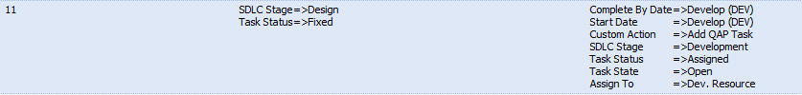

New

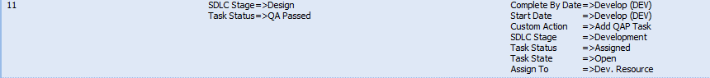

* + Add the below 3 new workflow stages

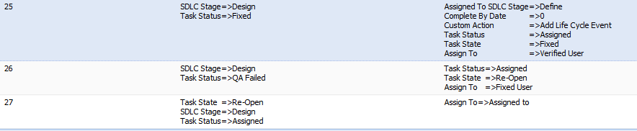

* + After completing all the workflow changes save the workflow and map the created workflow to the team which we need to have SDLC attachment optional in workflow mapping window



# Bug Fixes

* 1. **Bug Description:**

MSM loops into a refresh mode once I open up Extension Requests/Features to triage bands

**Bug Fix:**

Alignment issue in XSL. Resolved now.

# Known Problems and Workarounds

None